Application Design and Overview:

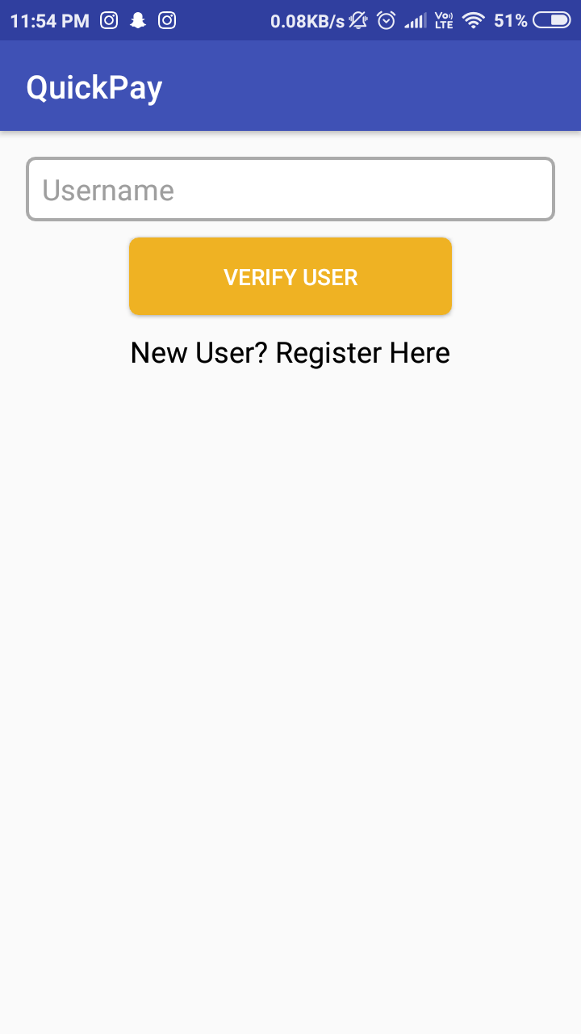 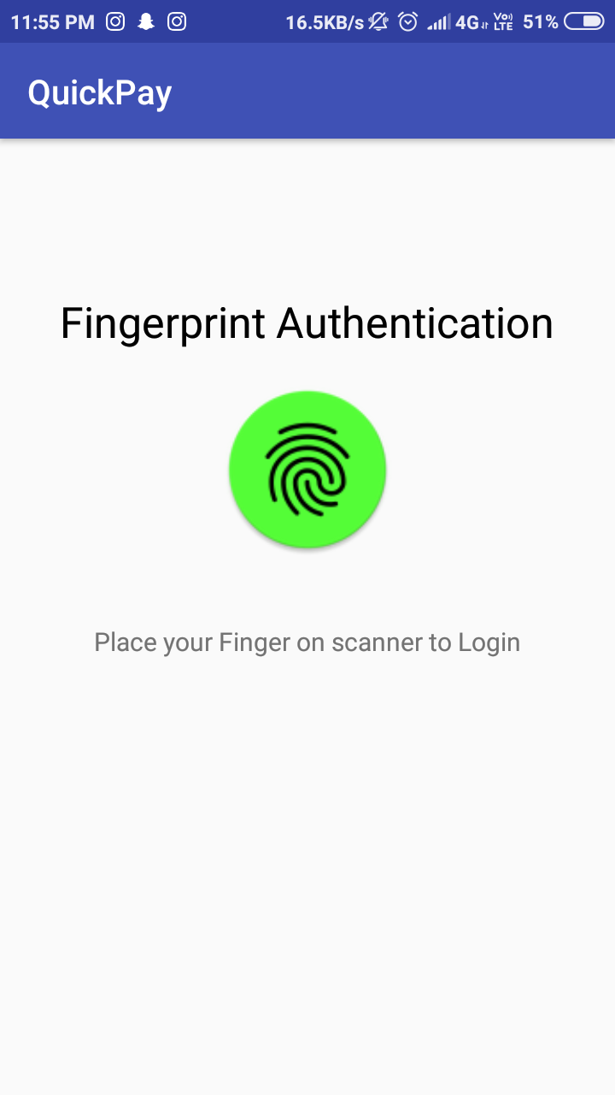

**FIG-1 FIG-2**

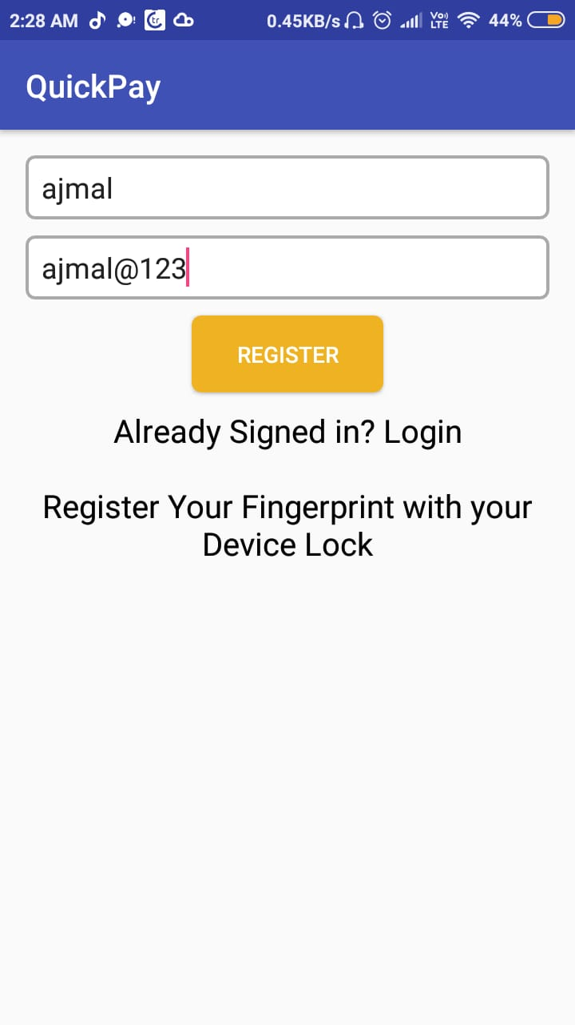 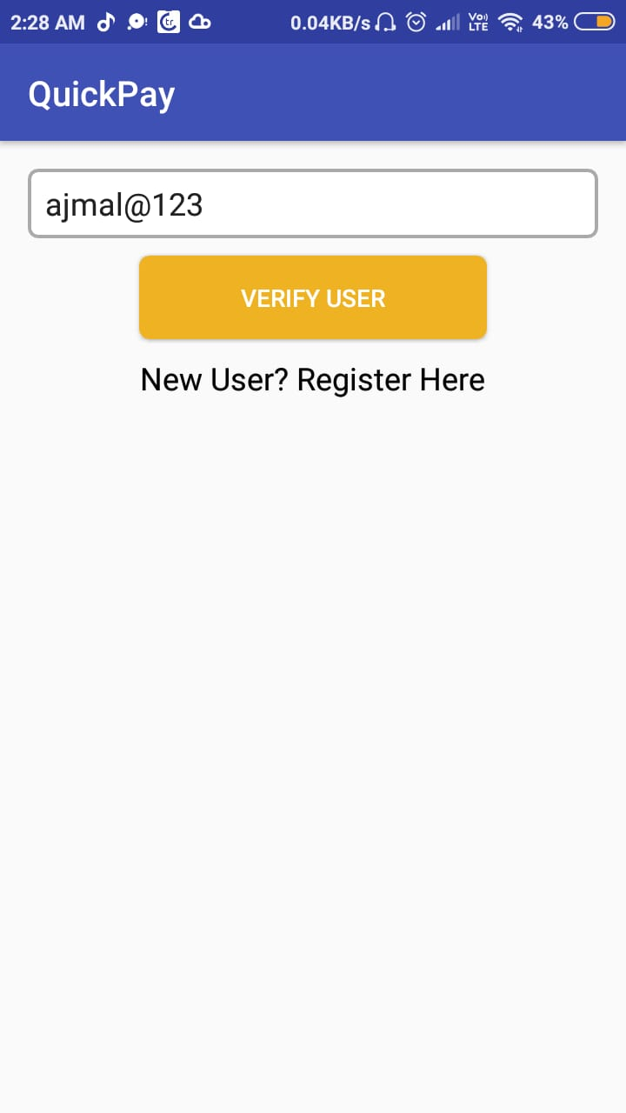

**FIG-3 REGISTER FIG-4 VERIFY USER**

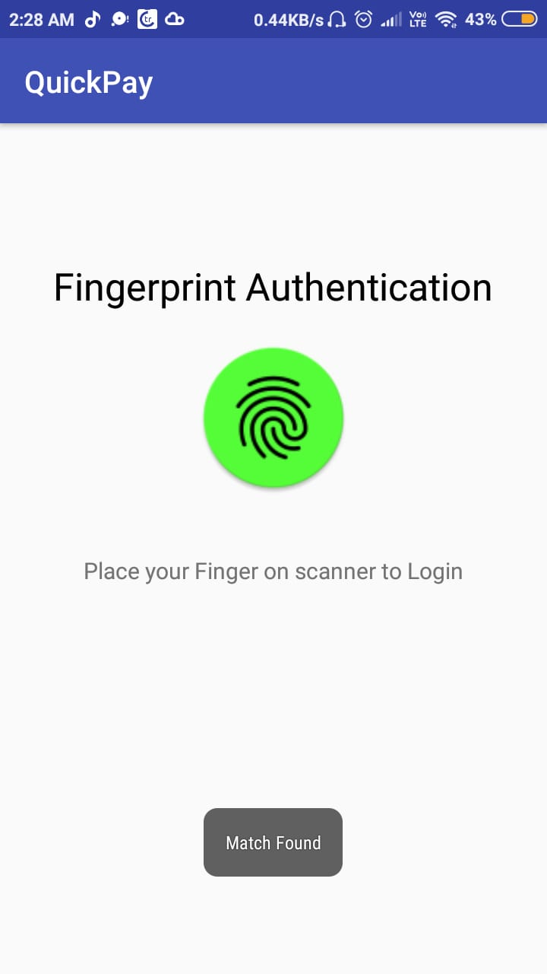 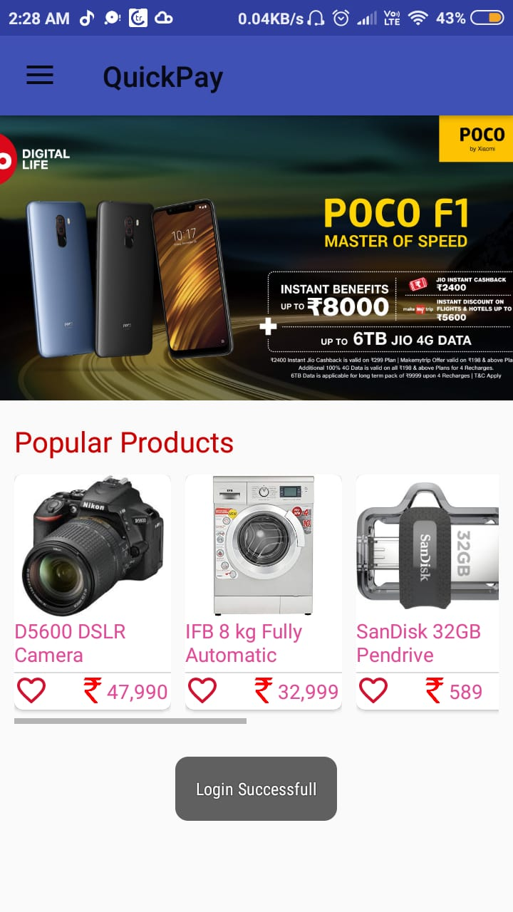

**FIG-5 FINGERPRITN FIG-6 HOME ACTIVITY**

**AUTHENTICATION**

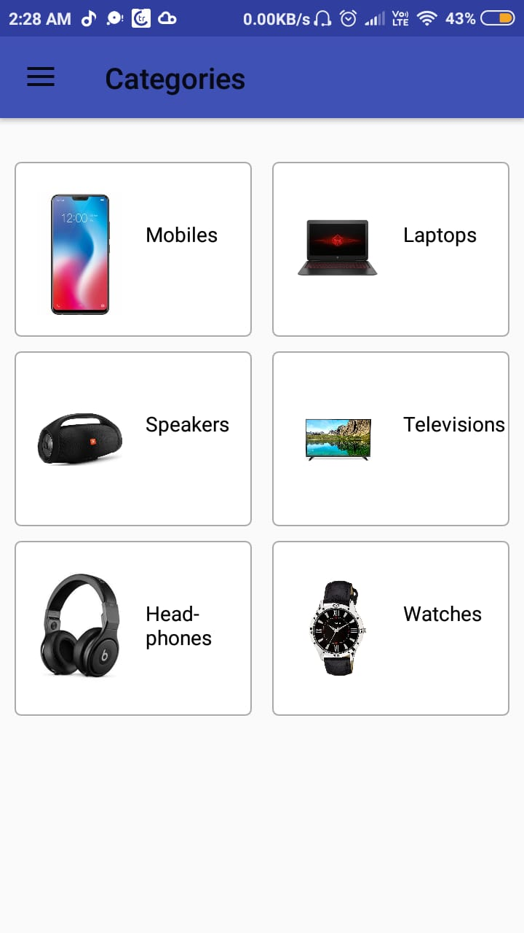 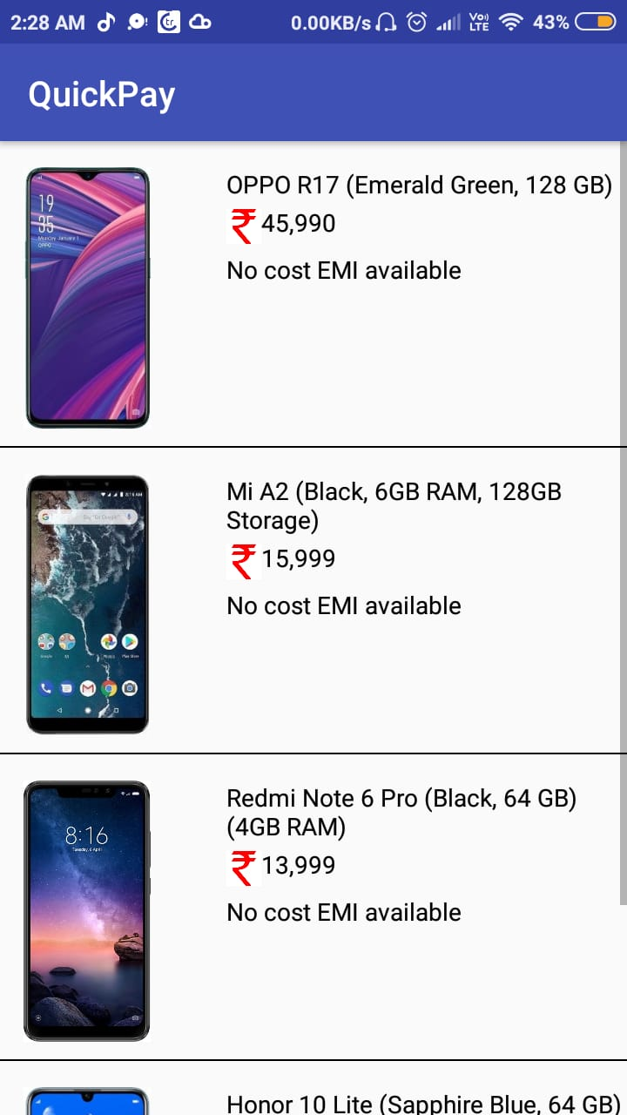

**FIG-7 CATEGORIES FIG-8 MOBILE CATEGORIES**

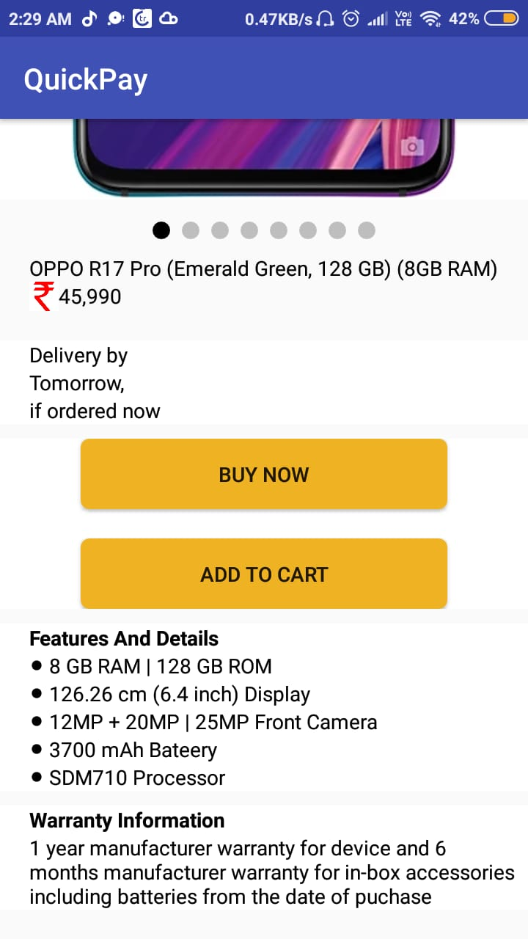 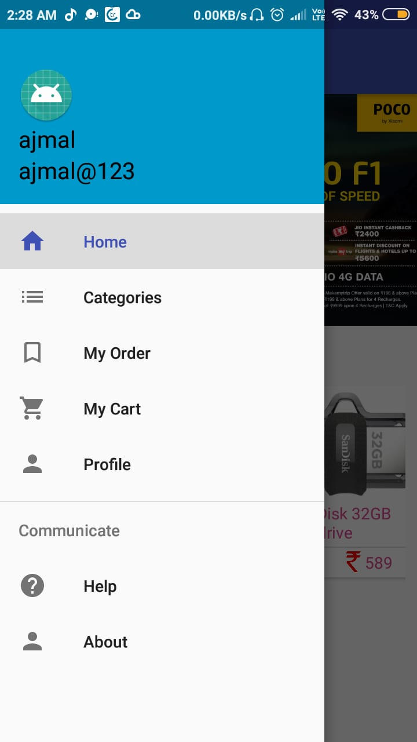

**FIG-9 PRODUCT DETAILS FIG-10 FRAGMENTS**

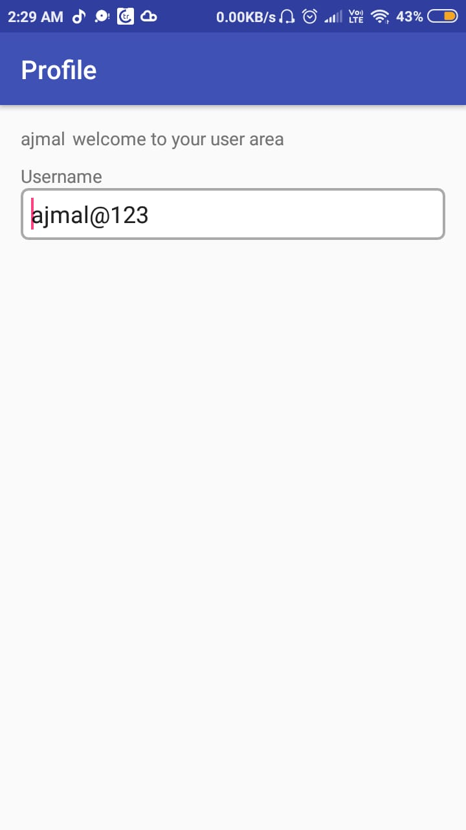 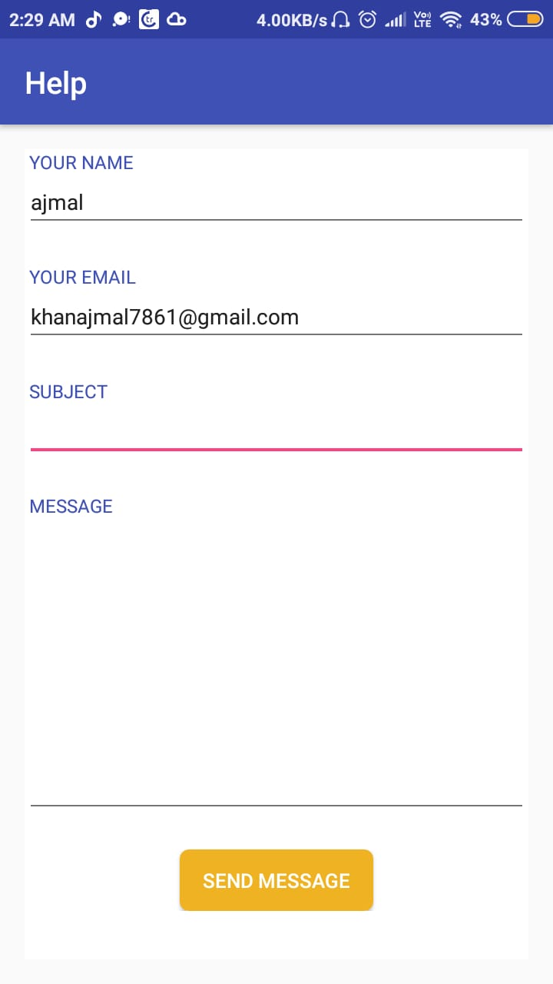

FIG-11 PROFILE ` FIG-11 CONTACT